JOE REEVES
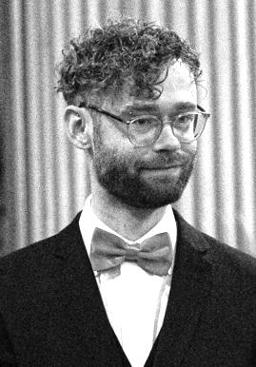
Joe first moved to Leeds from London in 2012 to study BA Music at the University of Leeds. He completed a Choral Conducting Scholarship at Leeds Cathedral and worked as a freelance community musician for five years. His work included a music and dance project working with people living with dementia, running community shows as musical director as well as a variety of other music and theatre-focused youth groups. He became conductor for The Wendel Singers in 2018 after the retirement of Joe Roberts. Over the past three years, Joe has volunteered at Leeds North and West Food bank and begun working in mental health. Now, he is a social prescriber, supporting and connecting people with services that can help them make positive changes in their lives.

LYNNE STAVELEY

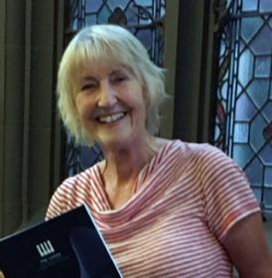
Lynne has been active in the musical life of Leeds since her schooldays at Roundhay High. She began teaching piano whilst still at school and sang in her school, church and later university choirs. Since that time she has continued to teach piano and has performed in numerous local concerts. Prior to its reorganisation, Lynne was a member of the Friends’ Committee of the Leeds Piano Competition; she is Chairman of the Christine Brown Trust for Young Musicians and an active member of the Leeds Music Club.
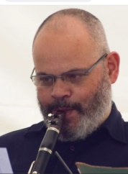
ANTHONY EMANUEL
Anthony is a Bradford-based clarinet teacher. He performs regularly at the Leeds Music Club and plays with the Oldham Symphony Orchestra.

Harmony & Humour—
entertainment for an
April evening by

The Wendel Singers
Conductor: Joe Reeves
Accompanist: Lynne Staveley
with Anthony Emanuel (clarinet)
Chapel Allerton Methodist Church,
at 7.00 pm
on Saturday 6th April, 2024

In aid of the church’s charity,
Oasis Relief Zimbabwe
Programme

Part 1
Jubilate Deo in B flat, Op.10 (Charles Villiers Stanford)
Last of the Summer Wine (Ronnie Hazlehurst)
All in the April Evening (Hugh S. Roberton)

Clarinet & piano: Alleluia from ‘Exsultate, jubilate’ (Mozart)

Locus Iste (Anton Bruckner)
Like a Mighty Stream (Moses Hogan & John Jacobson)

Interlude: Pauline Duncan Austwick:
Macavity the Mystery Cat (T.S. Eliot)

Like an Eagle (Carl Strommen)
I Am a Small Part of the World
(Sally K. Albrecht & Jay Althouse)
You Raise Me Up (Brendan Graham & Rolf Lovland, arr Roger Emerson)
INTERVAL

Part 2

With a Voice of Singing (Martin Shaw)
Ascot Gavotte (Frederick Loewe & Alan Jay Lerner arr Stephen Duro)

Clarinet and piano: Intermezzo (Charles Villiers Stanford)

Eriskay Love Lilt
(Trad. Arr. John Battley, adapted by Craig Mcleish)
Linden Lea (Words: William Barnes; music Ralph Vaughan Williams)
Interlude: Pauline Richmond: Lime, Jello, Marshmallow, Cottage Cheese Surprise (William Bolcom)

Selections from ‘Oliver’ (Lionel Bart, arr Norman Leyden)

THE WENDEL SINGERS

The Wendel Singers is a mixed choir of forty voices formerly based in Barwick-in-Elmet. We sing a great variety of four-part choral music, mainly short pieces, ranging from renaissance to contemporary, both religious and secular, just for the sheer pleasure of being together making music, performing occasional concerts anywhere in the Leeds/Garforth area.

The choir originated as the Barwick-in-Elmet Townswomen’s Guild Choir. After 1974 it became the Elmete Singers, still a women’s choir, which competed in the Pontefract Music Festival as well as performing concerts. In 1980 it became The Wendel Singers, taking its name from Wendel Hill, the site in Barwick of an iron age hill fort and later a Norman castle. It is now based at Lidgett Park Methodist Church.

Over the years it has had a number of conductors, including Adam Tomlinson, Forbes Doig, David Fligg and Glenys Heywood. Around 2006 its number had dwindled to single figures, but it gained a new lease of life when Joe Roberts took over as conductor and brought in new members, building our strength to more than 30 singers. After his retirement, his successor, Joe Reeves, has led us to a performance that gained a merit in the Rothwell Music Festival in 2019, and a commendation and First Prize in the 2022 festival.

